EMAX-RAP-Day26-2- 12.05.2026

Associations and compositions:
Here we are going to use the multiple entities. like parent and child relationships ..
when we going for the associations concept -- there you are getting the read only applications. means selected header and navigating into the item level in object page level. --> you are going to display the selected items.
Associations : one entity is associated with another entity but both can exist independently and without having any relation also. before association both are exist independently . but we are making the relations in the form of the associations.
ex: take the sales order, which is linked to the customer but customer can exist without sales order also. but sales order is reference to the customer..
Associations : like a navigation part, it helps you to read the related data.. / to navigate to the object page.. / join entities ..
Compositions: child entity depends on parent entity, child can't exist independently.
Ex: sales order header and items. means item can't create the without header. child entity complete depends on parent entity.
you want to create the items for header --> needs to create the association/relation to the parent, from the parent needs to create the child. --> called as composition.
compositions --> paraent and child, child and parents.
when it wants to make a relation from the child to parent --> you have go for the associations.

Example
created two tables :
travel header - ZTRAV_HDR
travel items - ZTRAV_ITM.
Header table:
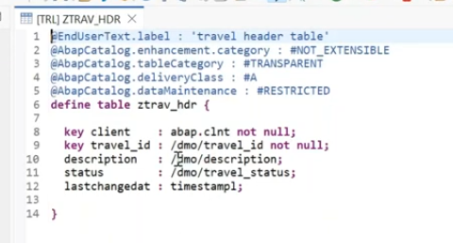
Item table
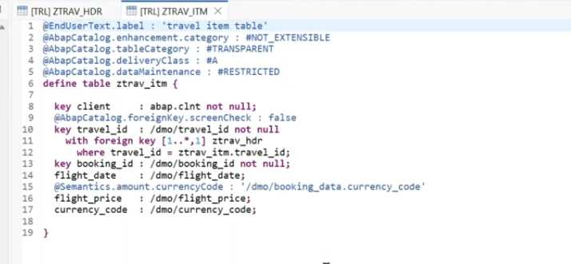
Now create the associations and compositions:
1. Create root entity:
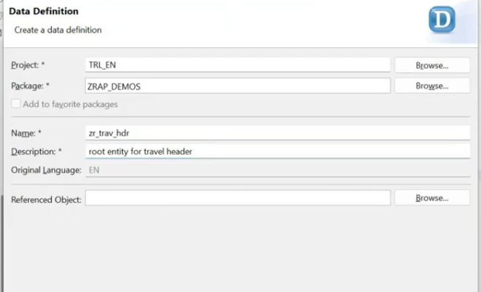
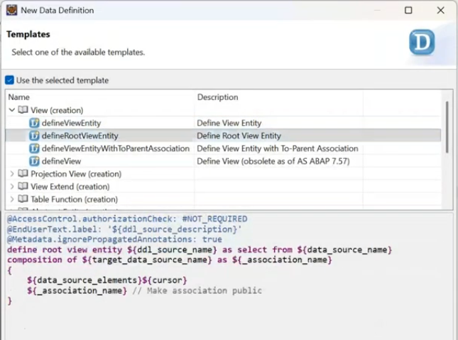
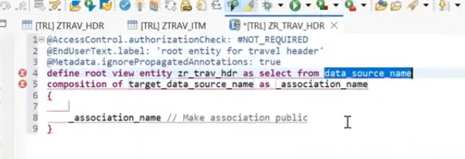
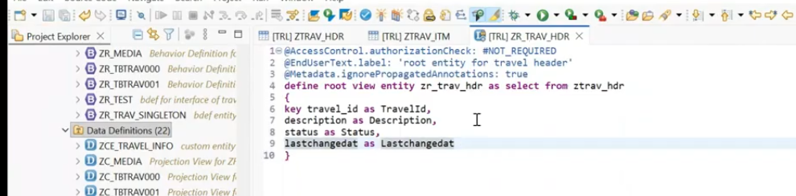
create normal view entity for items also
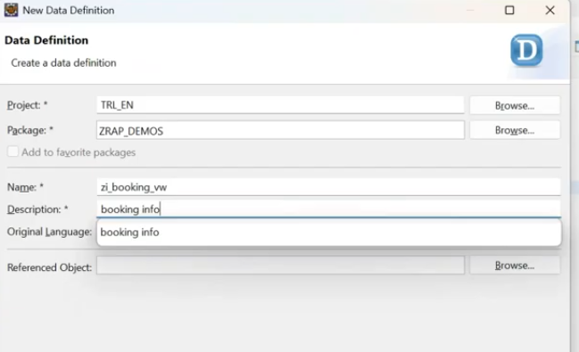
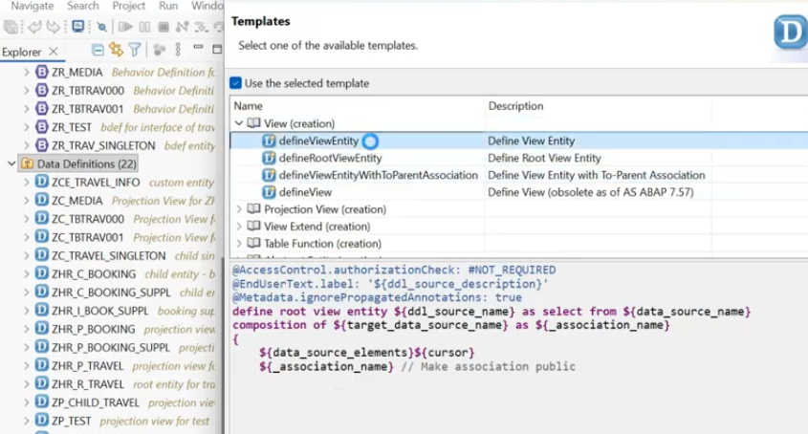
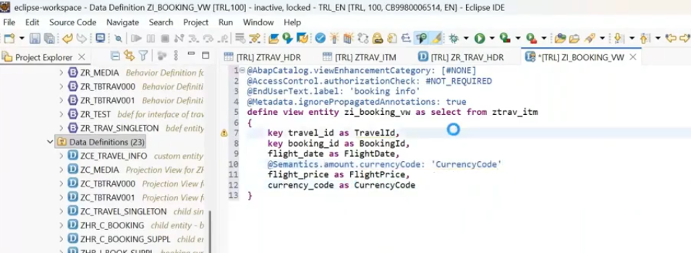
activate both entities.
from the item perspective, you need to make a relation to the header. --> in this case parent here is travel and child is booking.. from the child firstly you have to make a relation ship which is like a foreigh key relation ship.
use syntax: association to parent <parent entity name> on <child field> = <aprent field>
and use the header assocition in field list in child entity.
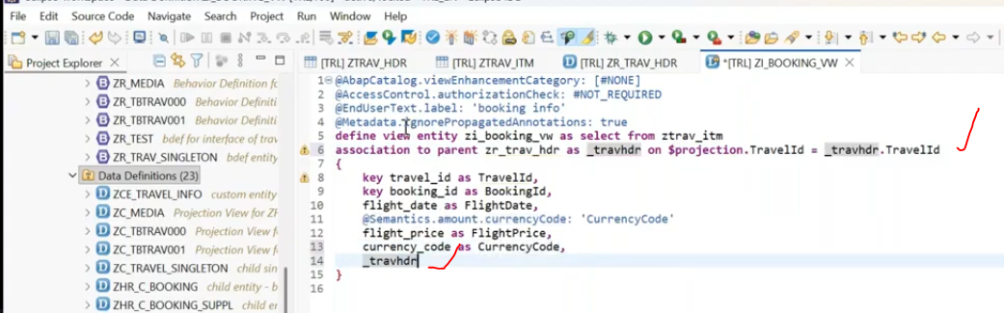
save and activate.
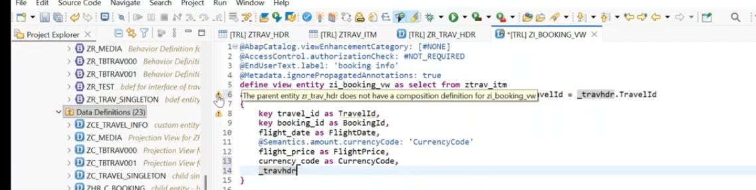
save and activate..
once you specify your parent entity immediately it is giving a warning.. what is that warning... the parent entity zr_trv_hdr does not have a composition definition for zi_booking_vw.
means you have to create the relationship for child entity data in header level using composition.
syntax : composition[ cardinality ] of <<child enity>> as <alias name>>.
and expose the child entity at assocation level.
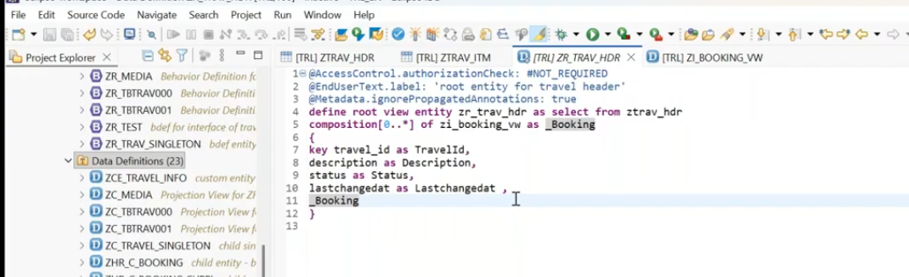
save and activate.
we have to create the projection view for root entity separate and child entity separate.
because in projection view, you have to define, you have to redirect to the parent, from the parent you have redirect to child. --> it is having the relationship between the entities. -> you have to connect projection view as well.
58:00
Create projection view for ZR_TRAV_HDR.
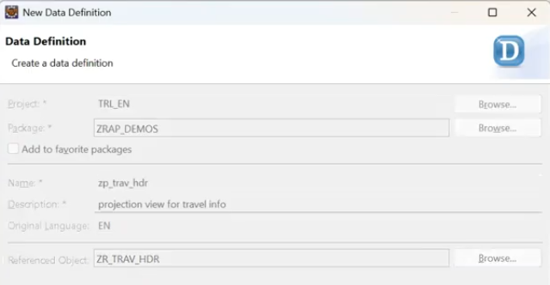
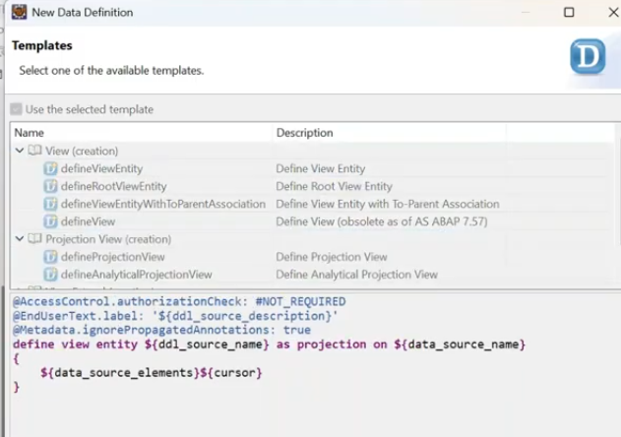
click on finish it.
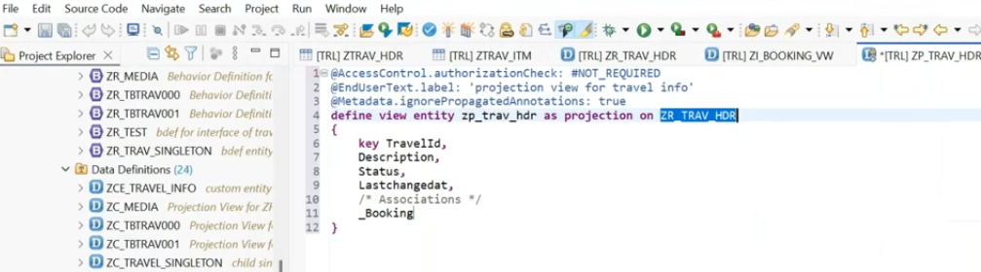
now base entity having root property projection view also.. add the root ..
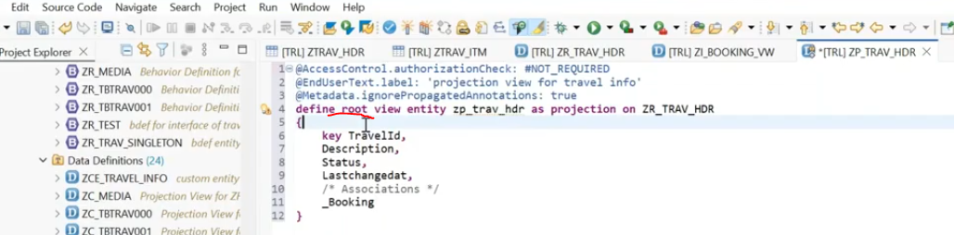
now add the annotations. in these annotations we need to create for header and item because when you are navigating, it also need to be displayed item level. for the item level also you have to create.
59:00
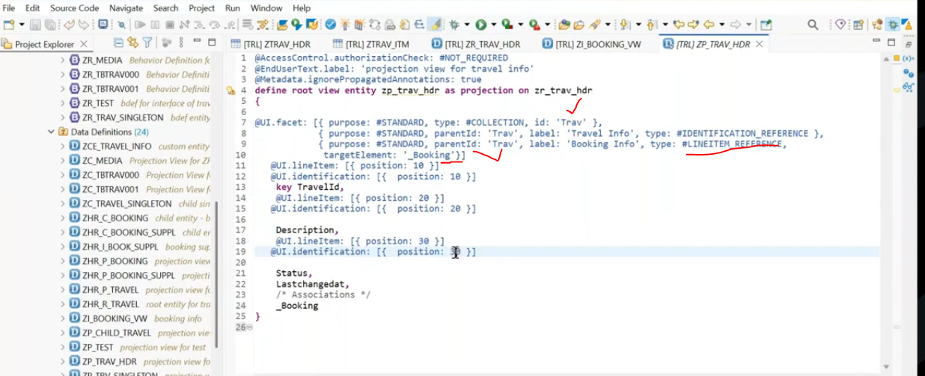
Create projection view for ZI_BOOKING_VW.
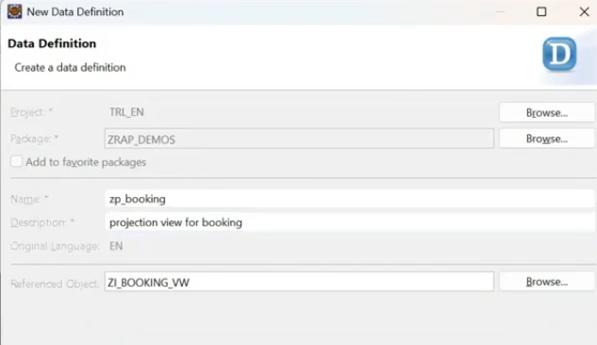
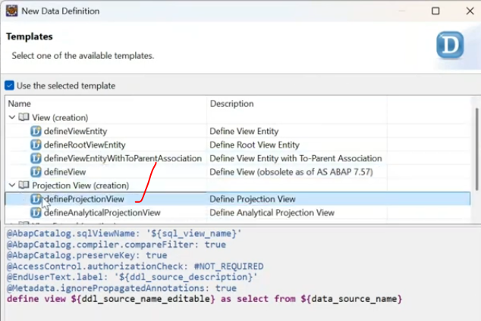
create projection view for normal view entity as well, it is not comulsory to have the root for entity.
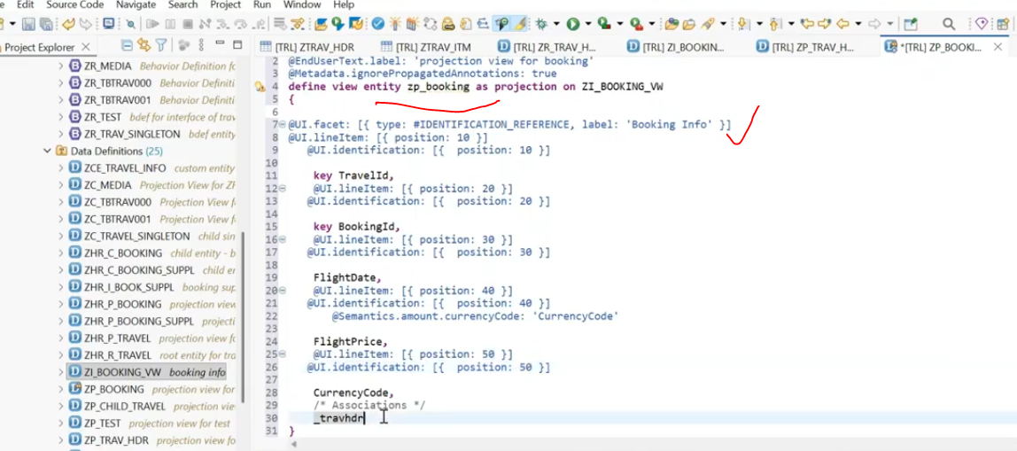
after this you have to connect the projection view, which needs to be navigate from parent child. in this(chil projection view) our parent entity is _travhdr
in parent projection entity -zp_trav_hdr - child association is _bookings , from the parent entity to i have to navigate to the child entity.
syntax: <<chik entity alias>> : redirected to composition child <<projecion view for child>>
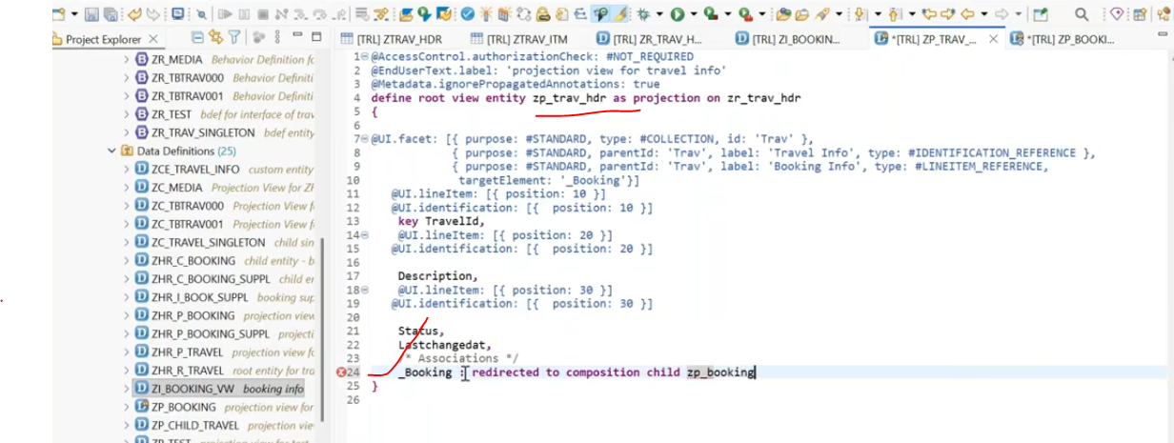
lly in item also for header.
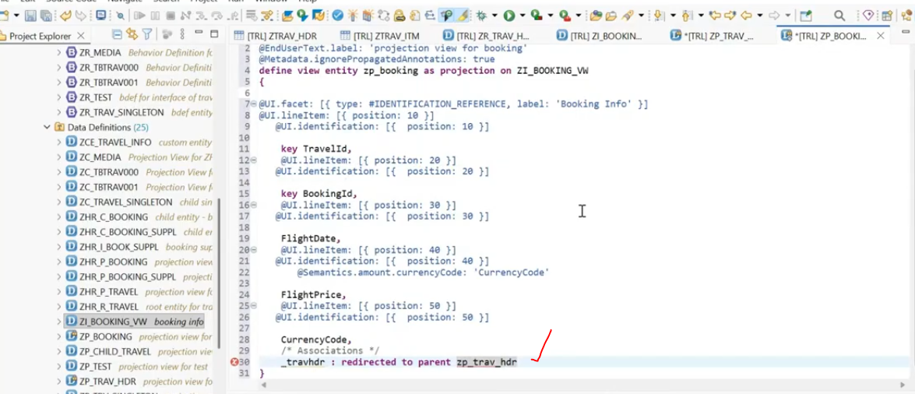
activate all the objecr
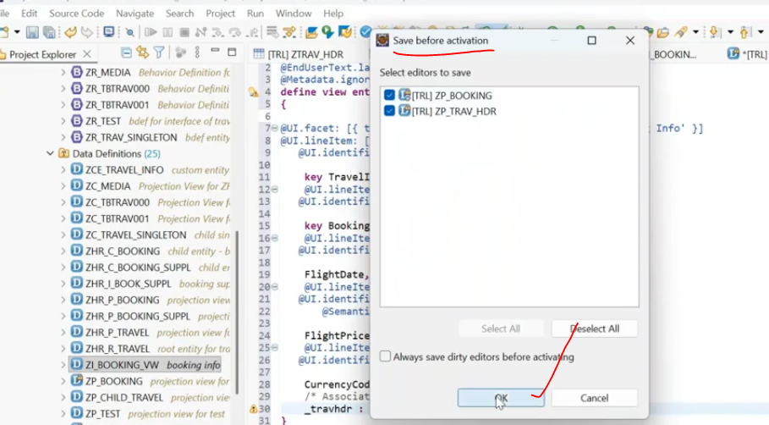
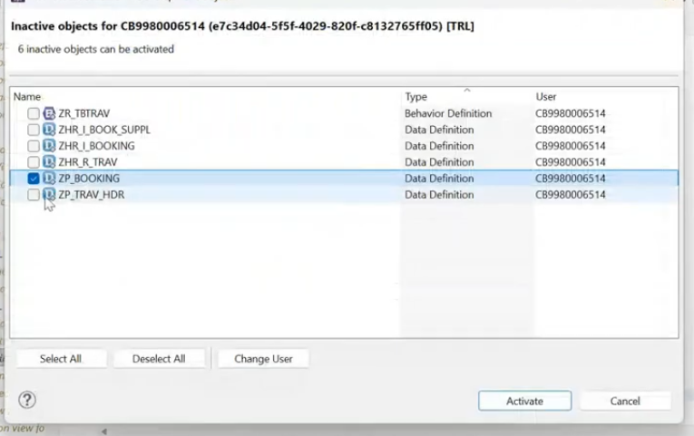
then it will be activated all the entity
lets create behavior definition on top of projection view.- managed scenario.
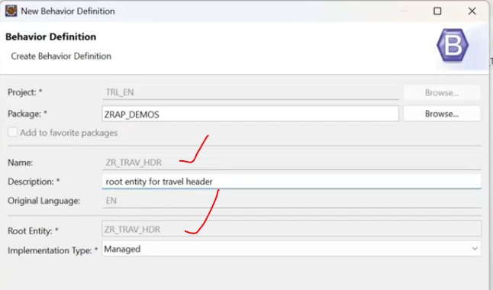
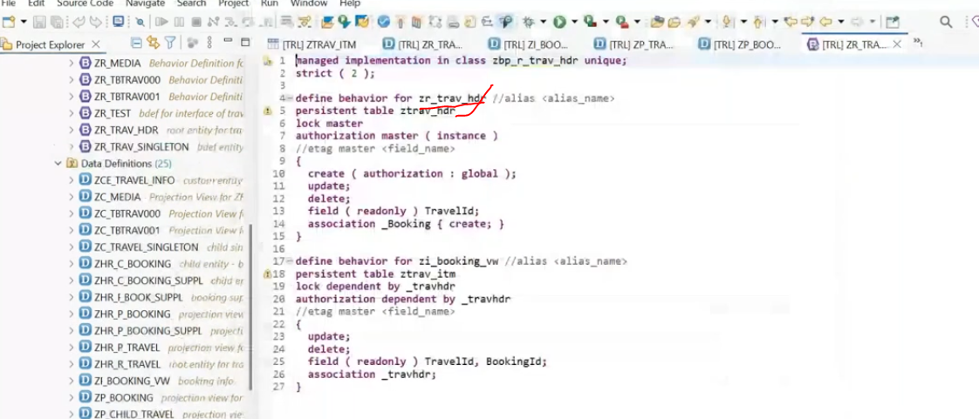
change alias name for header and line item.
1:07
header alias - trav_hdr
item alias -i_booking ,
Why two behavior's added in behavior implementation. - because you create an association, you create an composition, how you create a composition, how you built it because you made the composition then it will be consider that child entity in a behavior definition - then you are allow to create child entities also. that's why you are getting behavior header and item.- because of the composition .
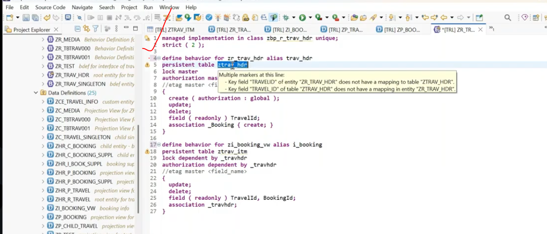
lock functionality of line item- based on header locking ( lock dependent by travel hdr in line item.
Now apply the draft phase as well- hedaer and item both cases.
create two draft tables for header and item.
Header:
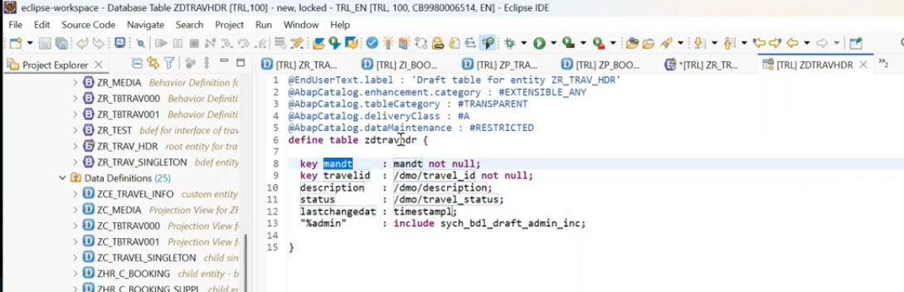
Item
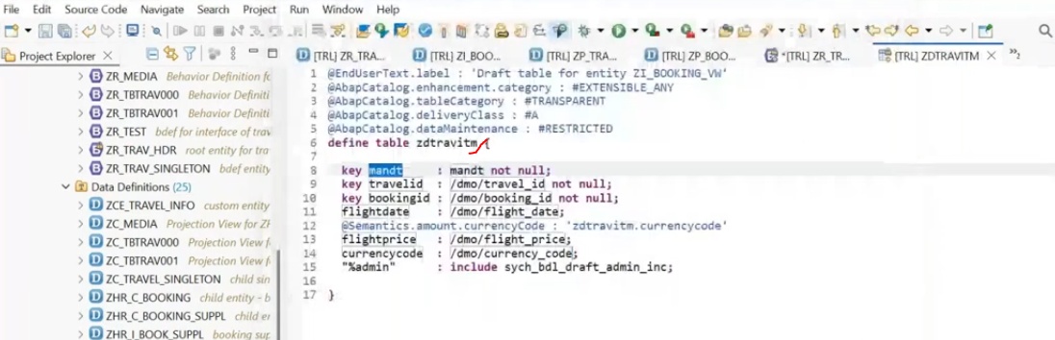
in behavior implementation, add the draft functionality
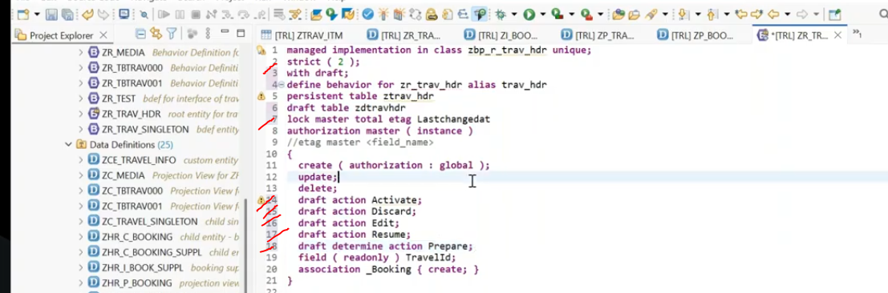
When you specify a draft phase at header level, compulsory you have mention that draft table for item level also. you no need to add the draft action with draft by as single behavior definition in item level- one draft phase it enough at header level. but only need to have draft table for item level- this enough not draft actions.- this only thing which we have to enable in item level(Add draft table only) at item behavior.
add draft table in item level- reaming actions are not required.
but how to store the data in draft item table use below syntax:
suppose if you want to create the draft for item also you have to specify in header, association for item to add the "create: with draft "
assocition "<<_item>>" ( create: with draft ) - it is also create the draft for item.

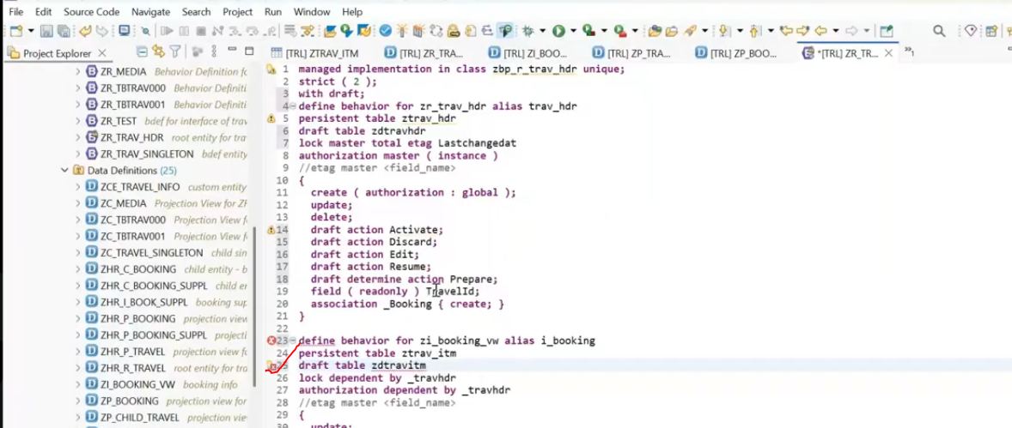
added only draft table in item.
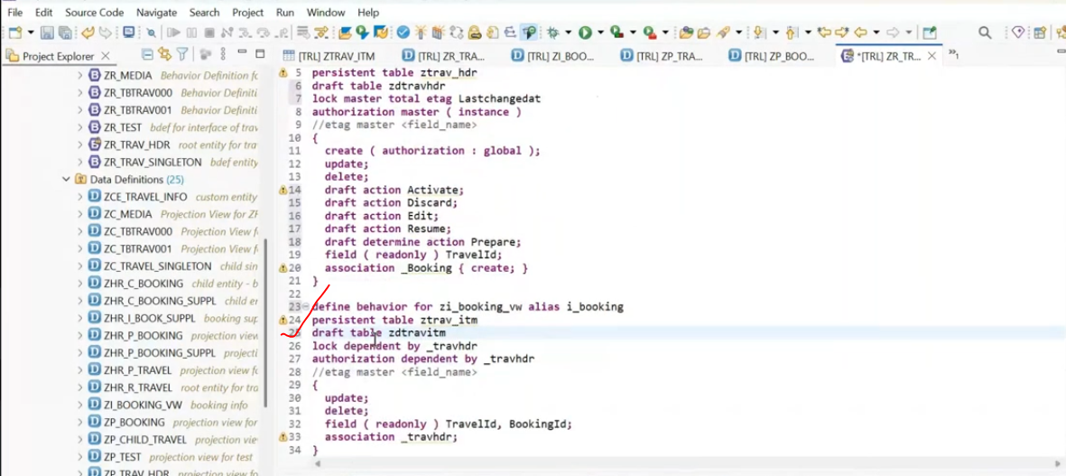
draft enabled for item:
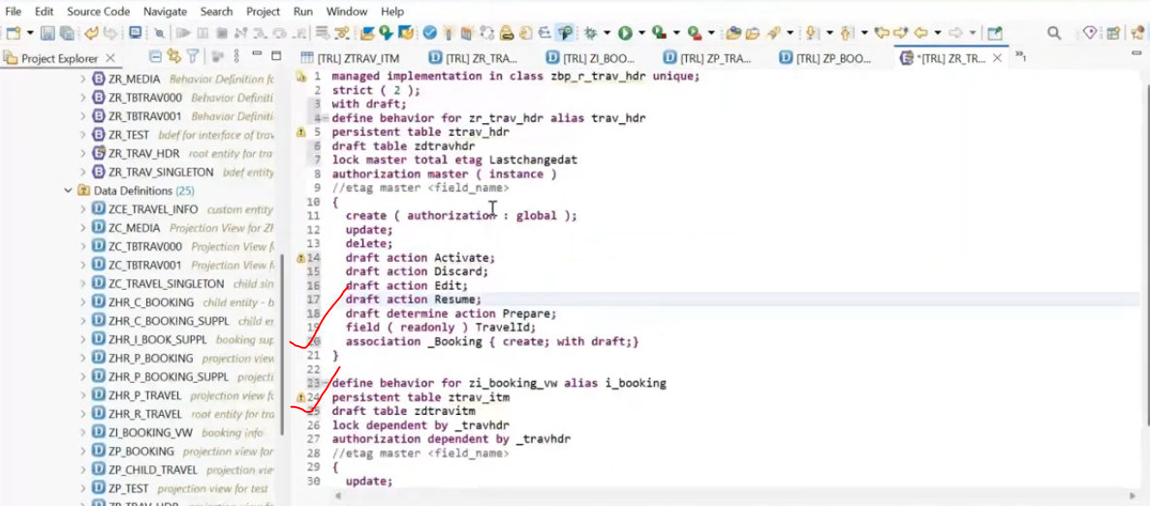
Now we can able to store the draft data in header and item also.
now adding the mapping in header and item to transfer the data view to table - in header and item also.
Header mapping:
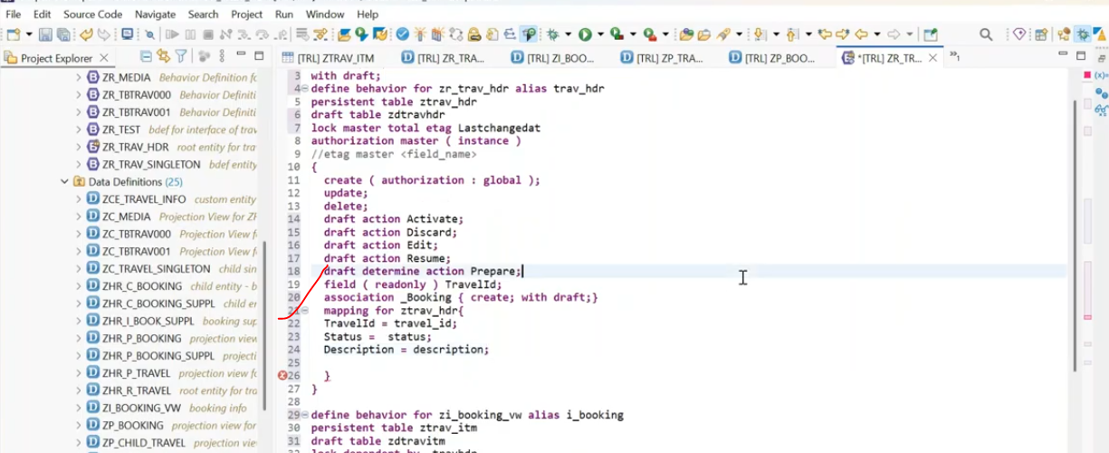
Item mapping
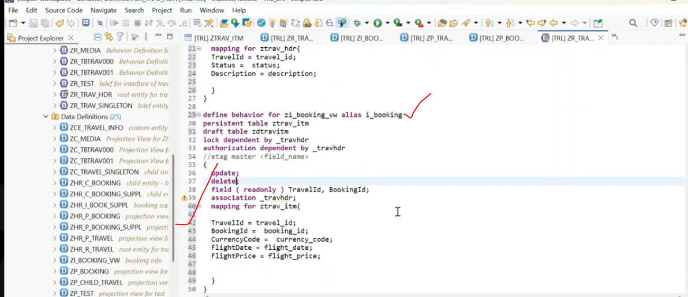
After creating a behavior definition for your projection view you are added the draft functionality then you have to add the draft and draft action in the projection behavior definition manually. before you create your projection behavior definition make sure that you are going for draft actions - so your draft all the code in the projection behavior definition will be automatically inherited.
implement the behavior implementation class. - select class in behavior implementation, press - ctrl + 1 to create the class:
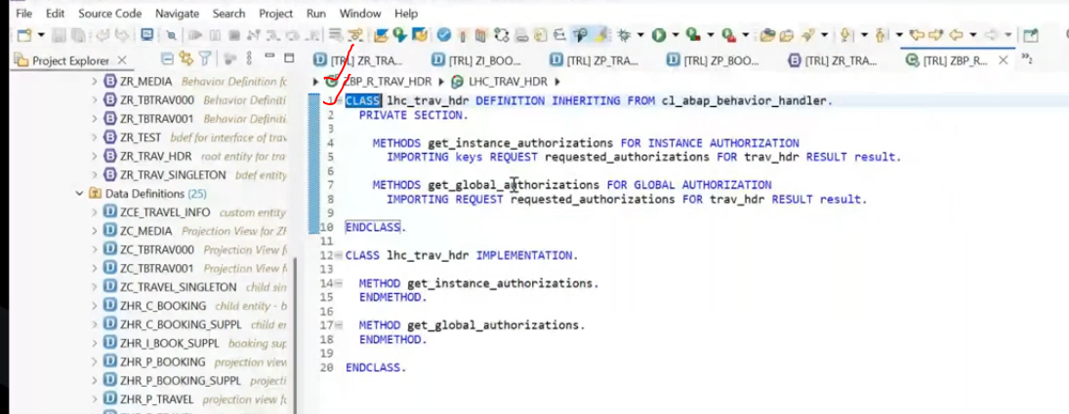
save and activate.
Behavior class and imlementation should activate.
Now create the behavior definition for projection view:
Projection view: ZP_TRAV_HDR:
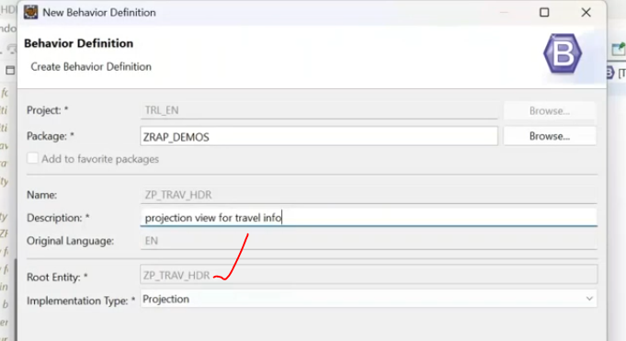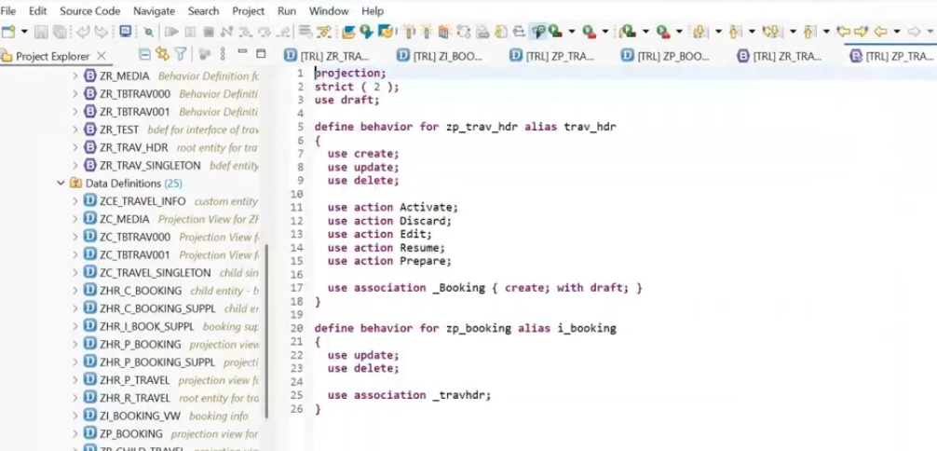

in behavior definition, select the projection behavior --> press -ctrl + 1 it will create the class.
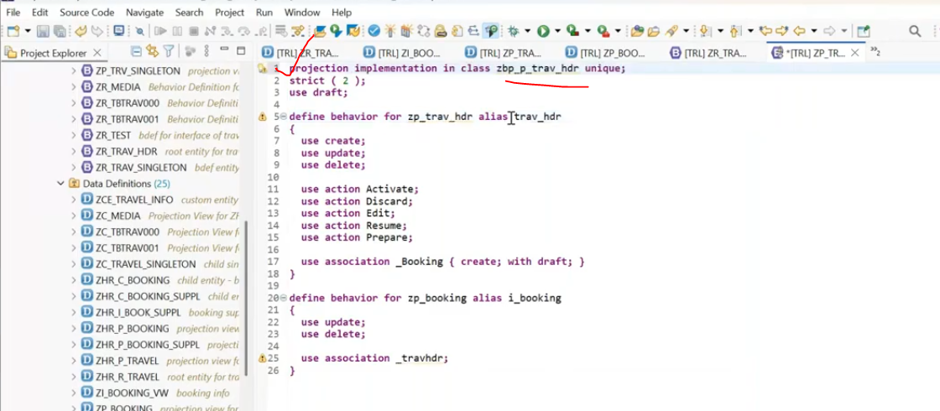
save and activate
draft is automatically added and draft actions also automatically added..
now implement the projection behavior class. - select the class - ctrl + 1
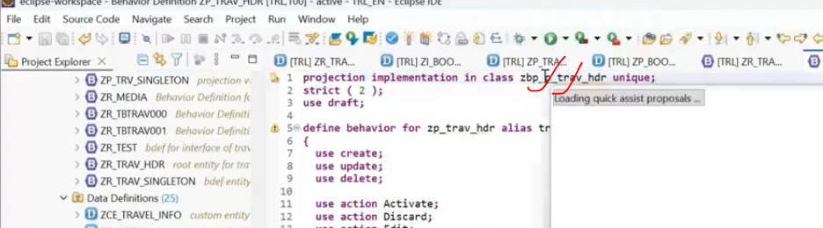
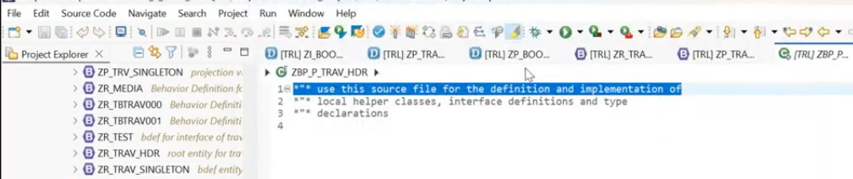
save and activate.
now activate all the objects which is implemented.
Lets create the service definition:
Service definition: on top of projection data definition.
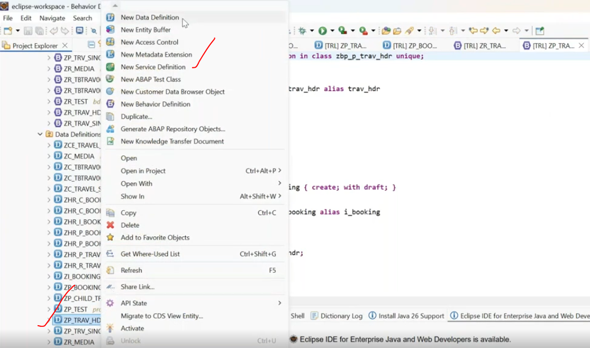
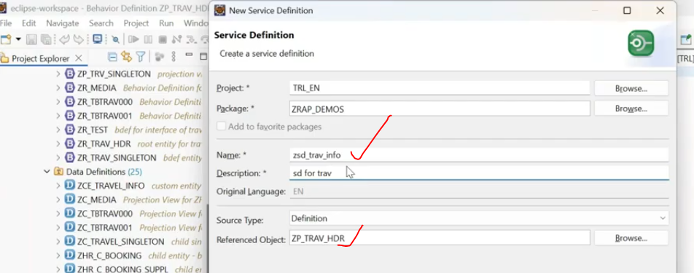
in same service we have expose the header and item data..
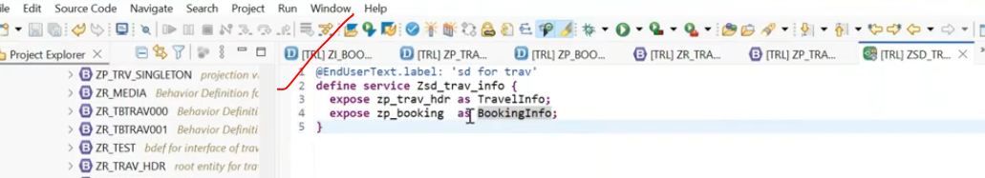
activate:
Once you create the service definition- create service binding.
Service binding:
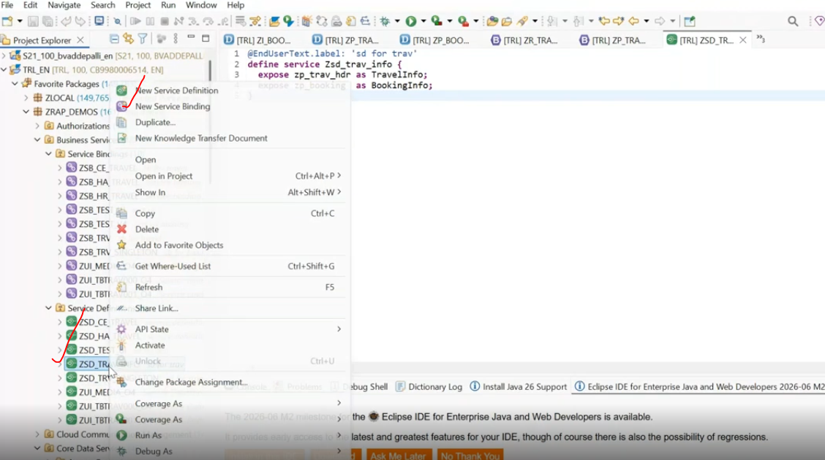
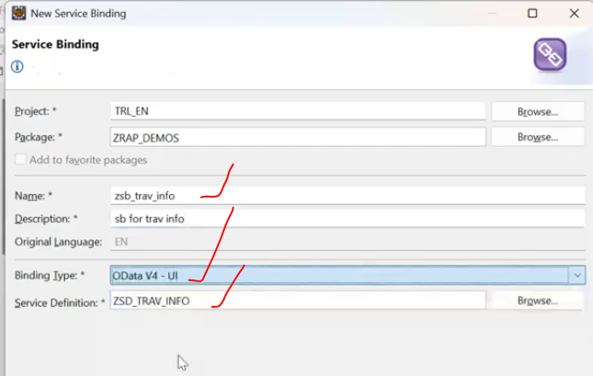
save and activate the service binding.. --> then only you can able to publish.
click on publish.
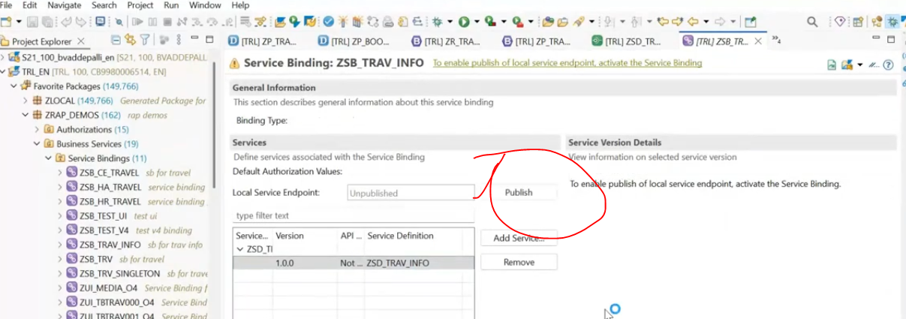
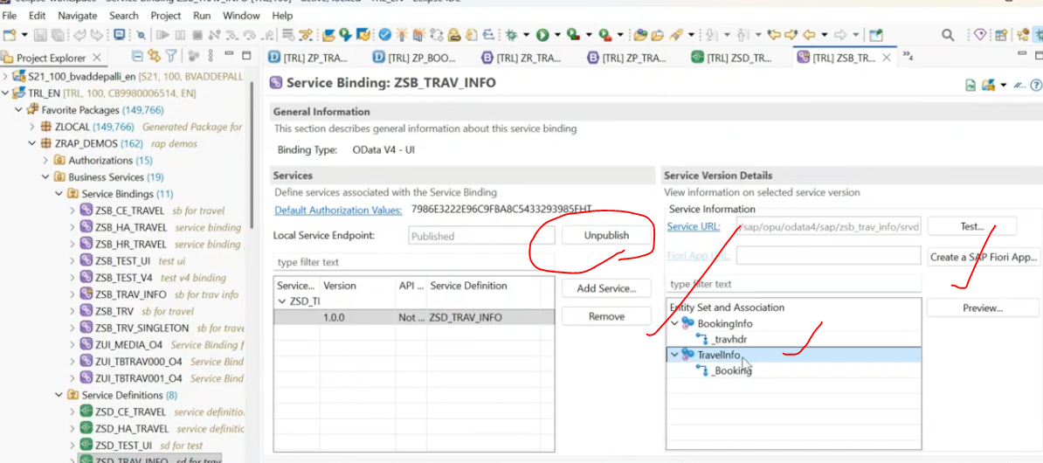
ALl are done..
Now test the process.
Testing:

Select the travel info click on preview.
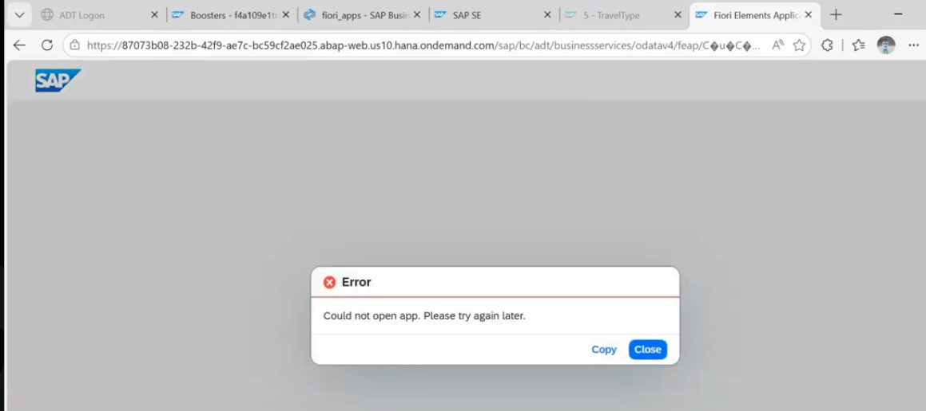
if you will get the error --> you have to create the communication sceanrio.
Communication scenario:
right click on package -- go to other abap repository object
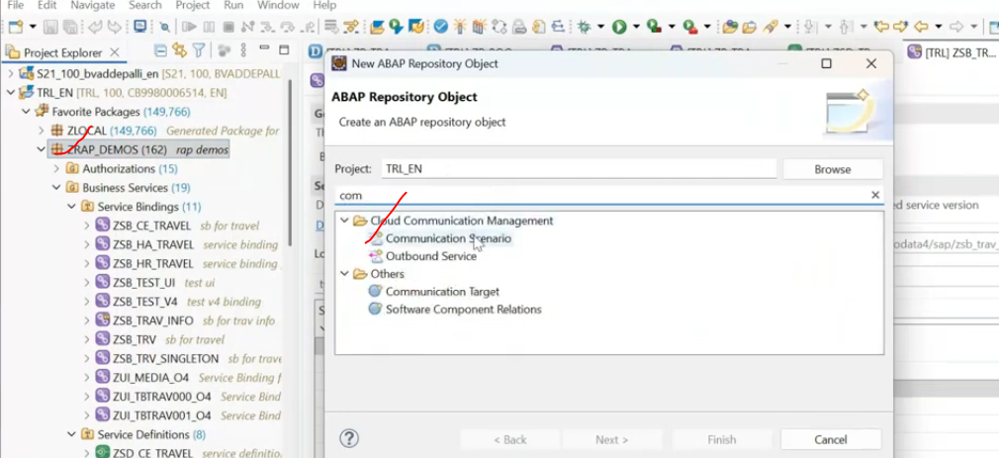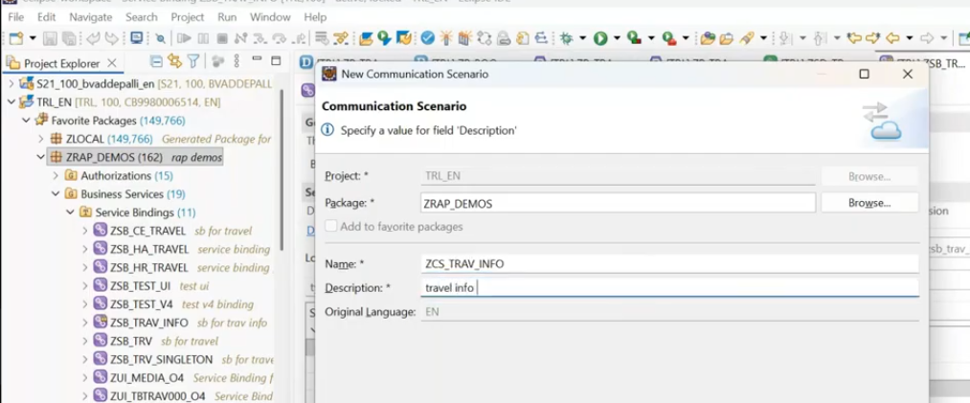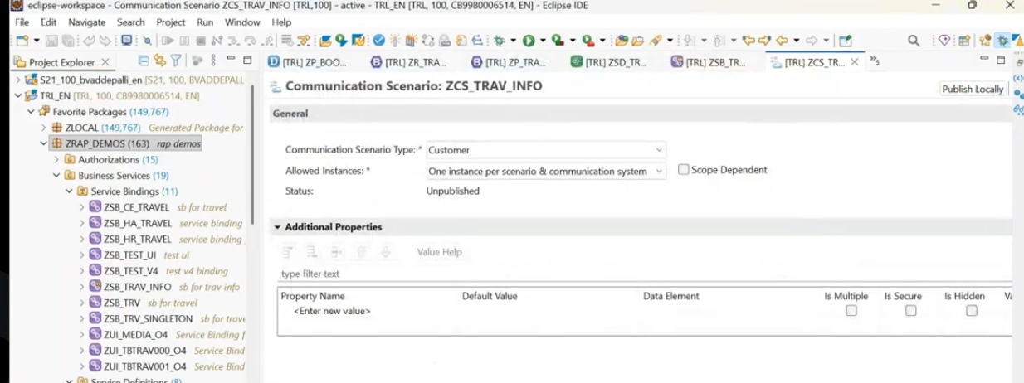
once done - we have to add the inbound service:
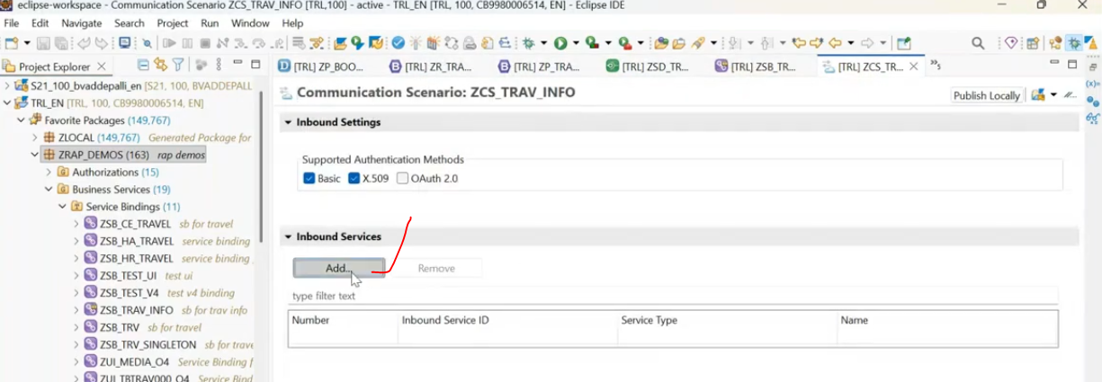
add the service binding here... which has already created.
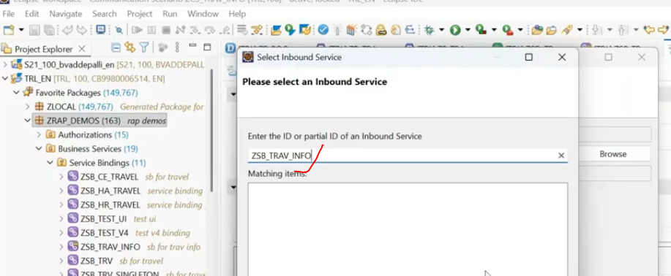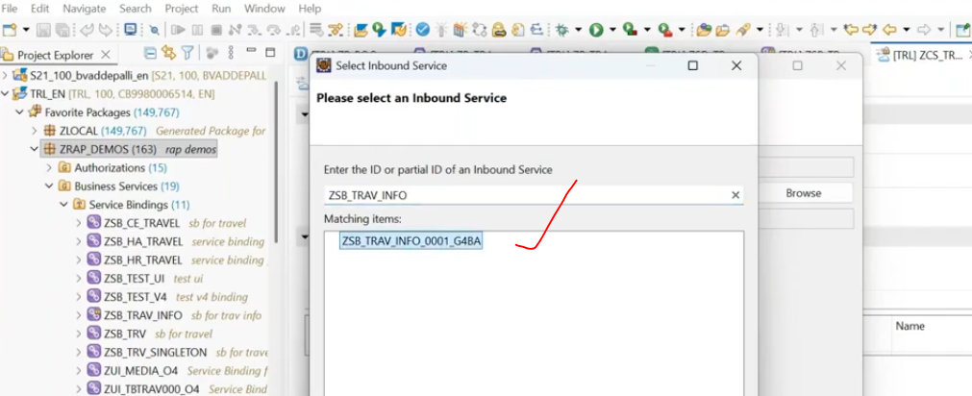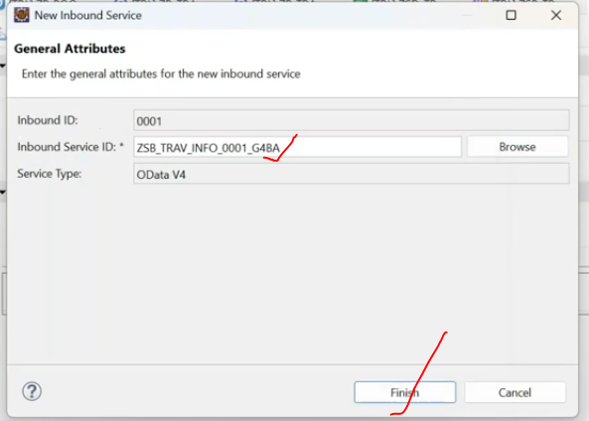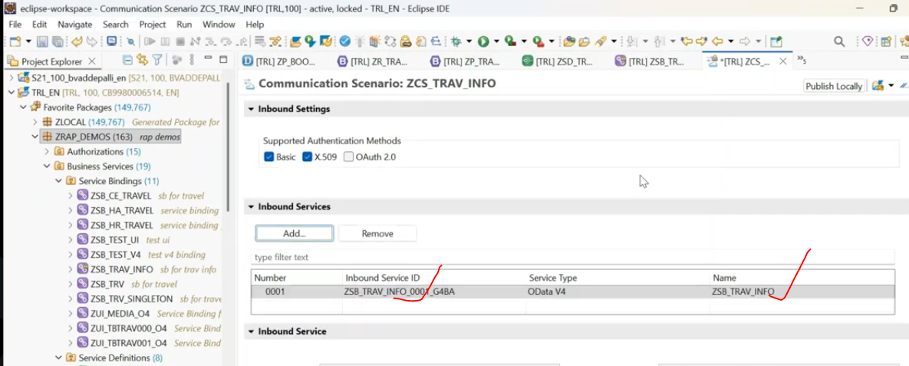

once it is added, we need to publish locally.
save first.
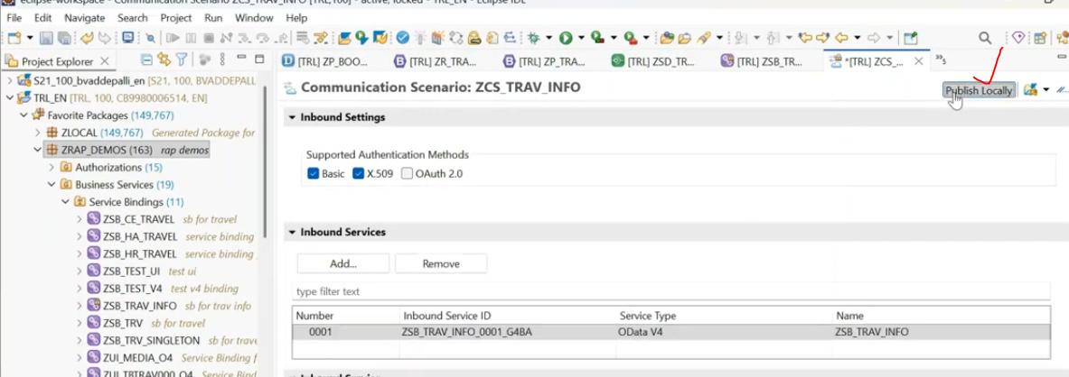
once published locally
again refresh the page at browser where error got:
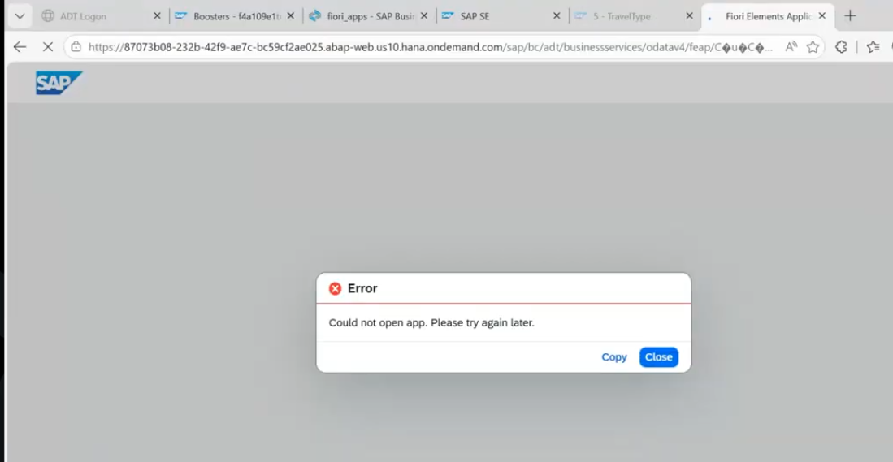
refresh it - still error persist.
again unblish my service binding and again publish the service and then test.
still error has persist:
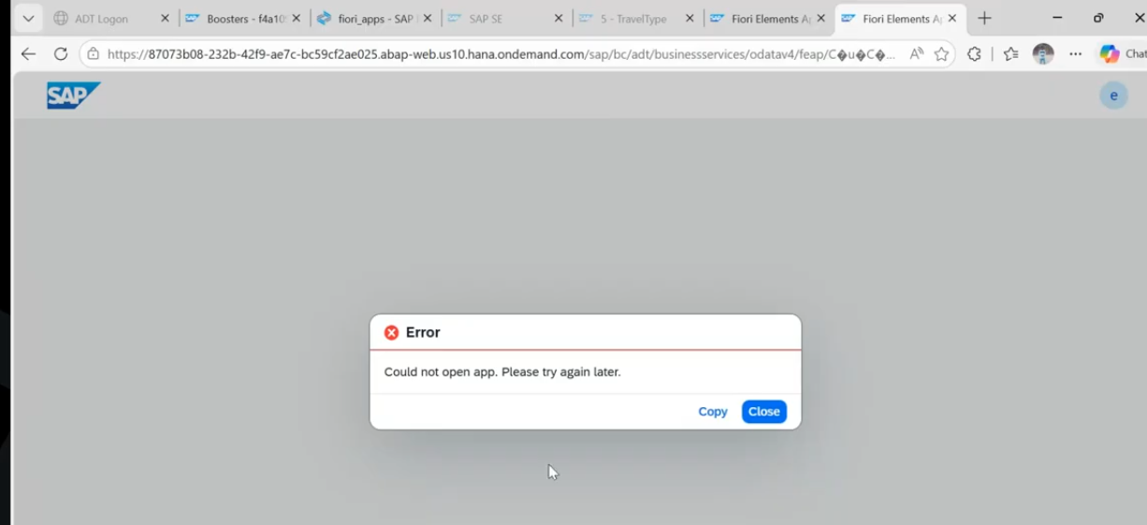
test application next class..
Whenever i am going to create the item data for this travel id, automatically the travel id has been populated to the booking entity.
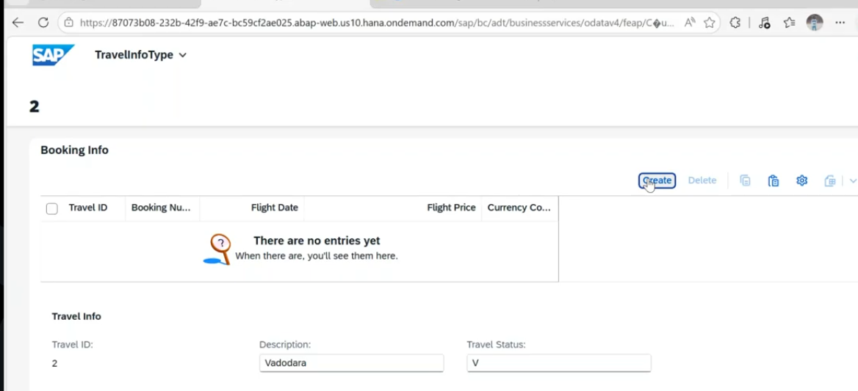
click on the create
it will sk to enter the new details. here not required to enter the travel id, just enter the booking number
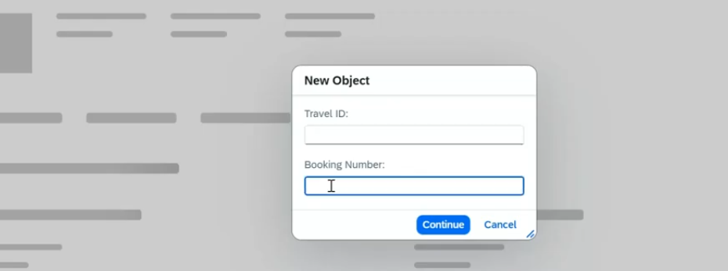
enter booking number as 10 -->click on continue.
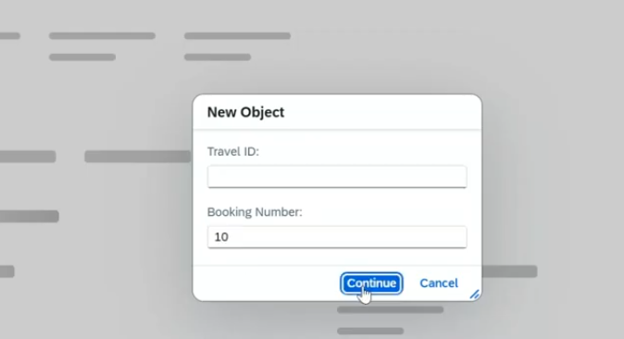
Automatically the travel id is assigned to booking info details
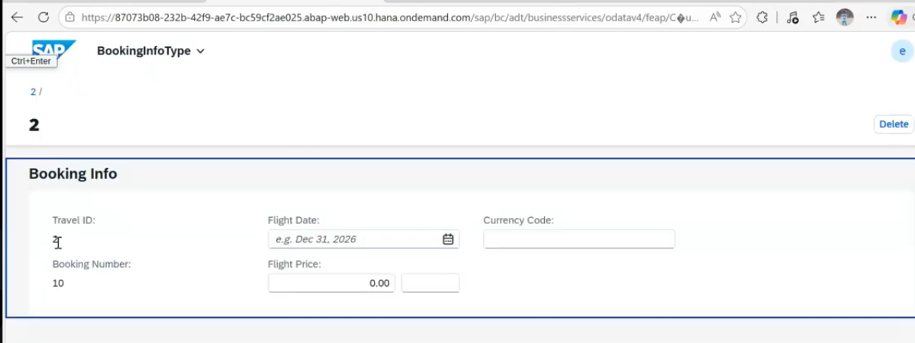
This travel id assigned from the header level..
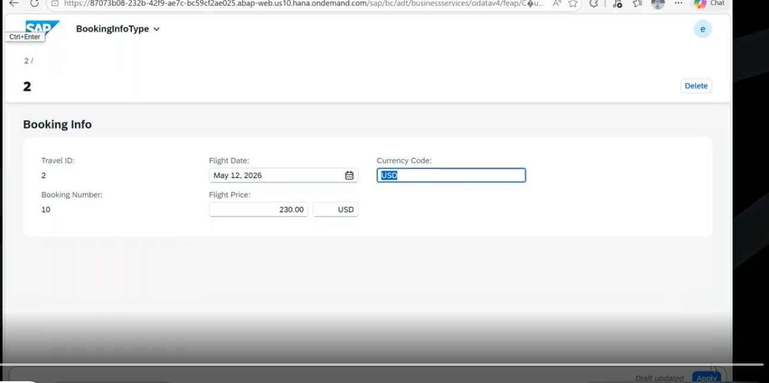
click on apply button.
this is one item.
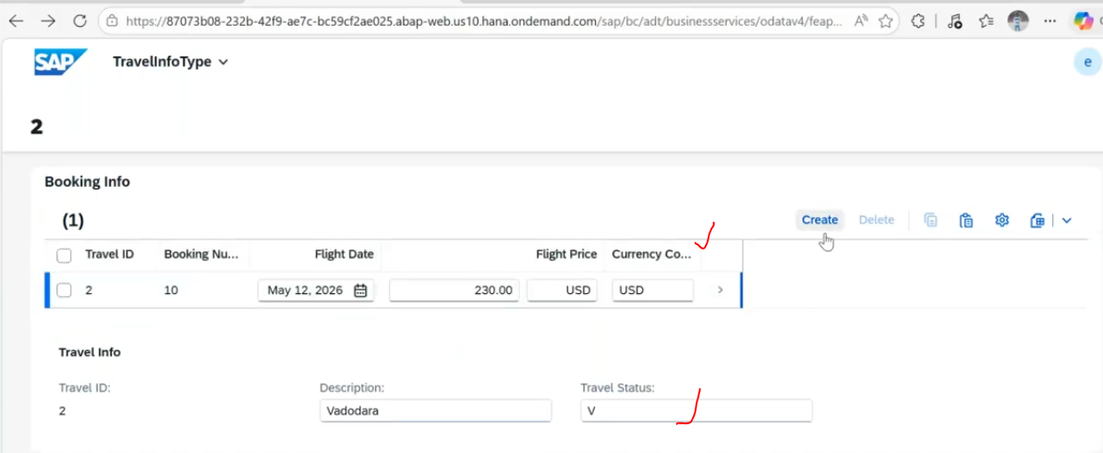
if you want to create the multiple item, again click on create.
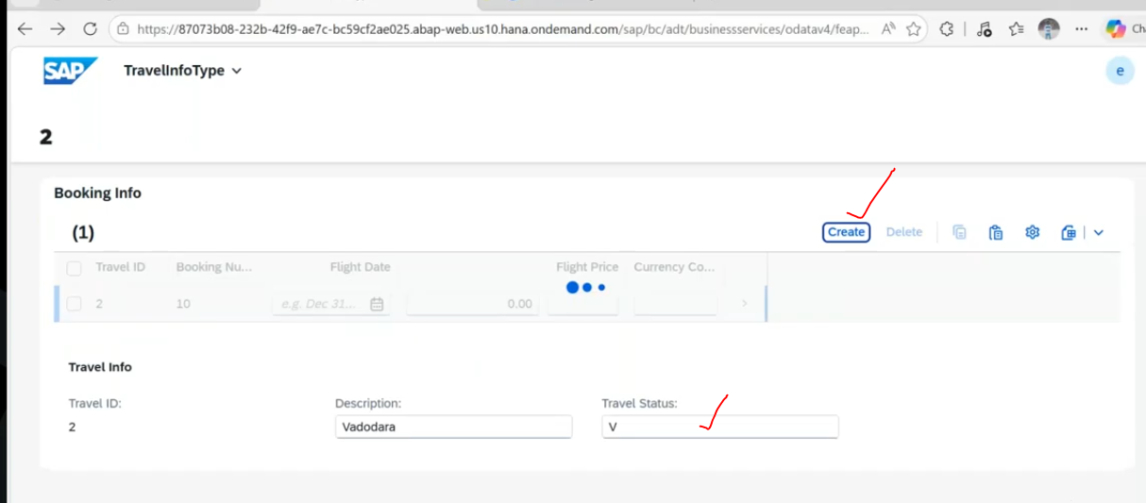
again provide the booking number.
this is time travel id is but item is different. then it should not be considered as duplicate.
here item is 20.
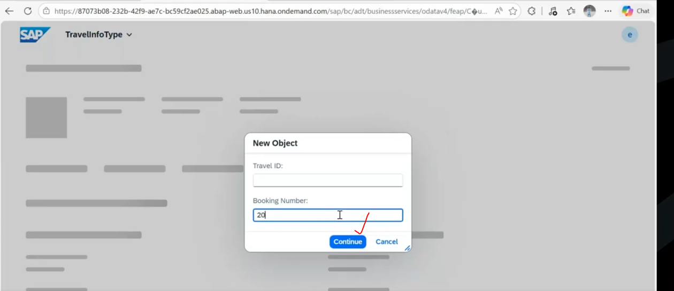
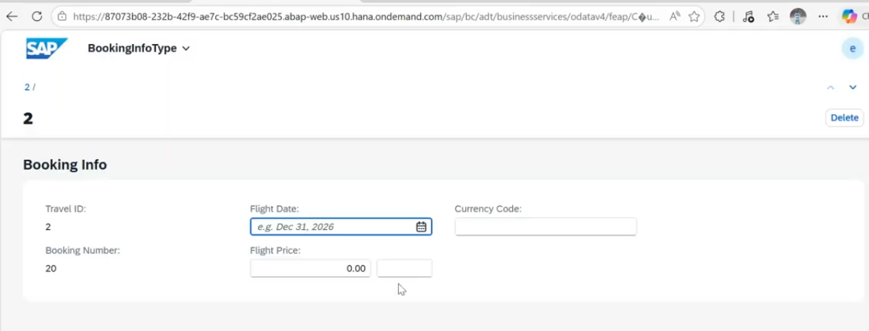
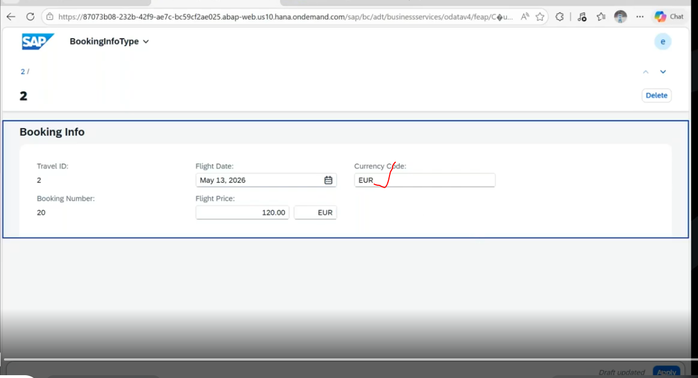
click on apply- item level another record has been created.
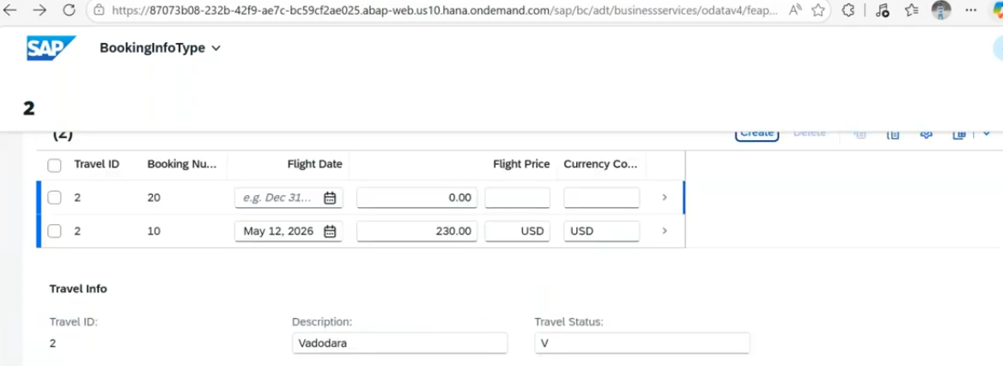
you can create multiple items like this.. -- above screen shots data has been not yet updated..
Once data is ready to update with ui5 level. --> click on create button.
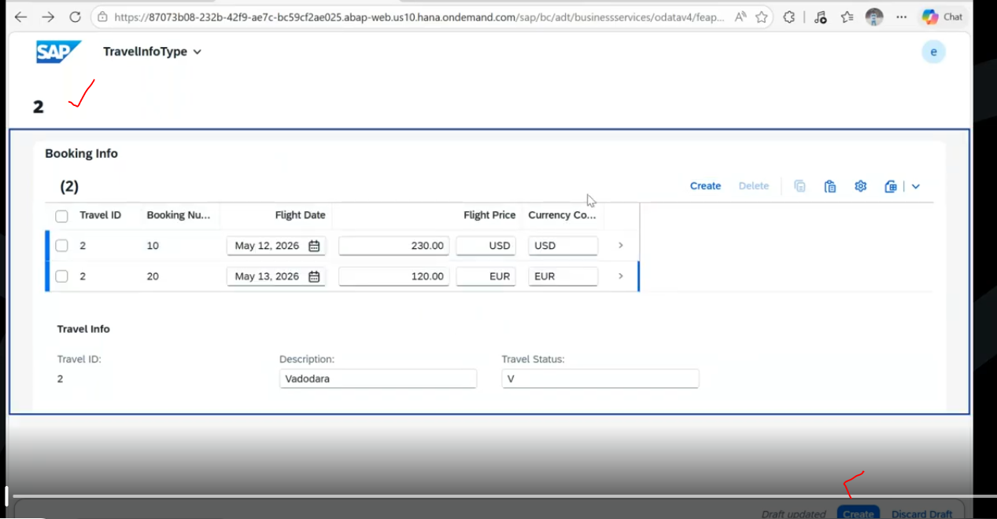
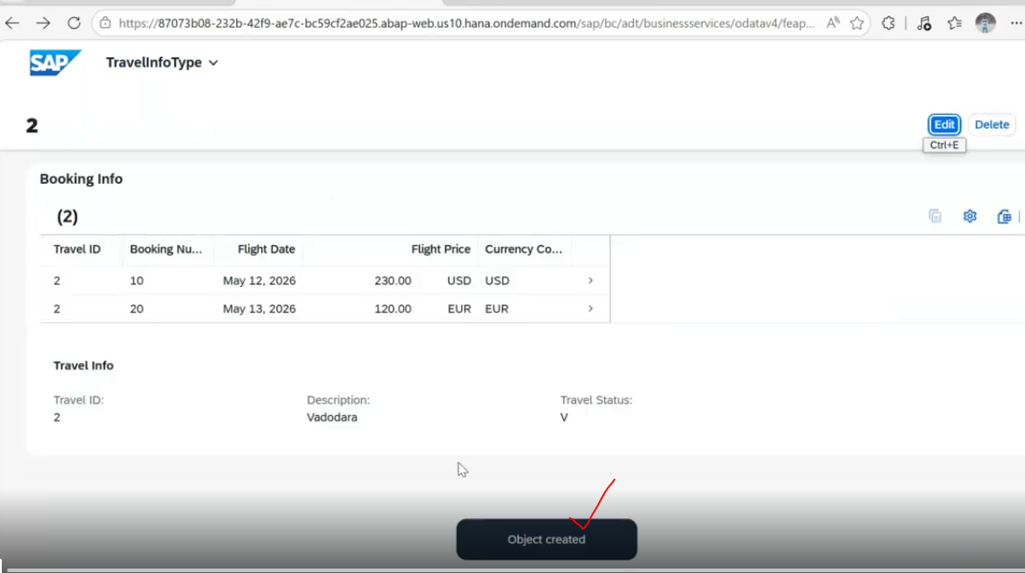
Now travel is created ...we have added the two booking records and we have added the two different id in booking entity.-> when you select the particular record -- you will be getting that record in object page.
if you want to update the data in detail page --> click on edit and update.
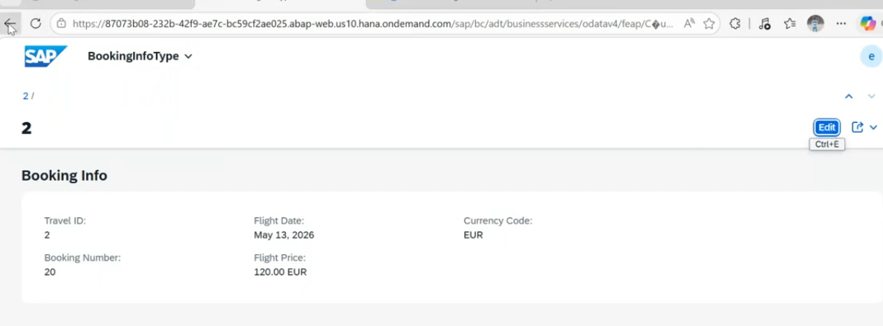
for mass update --> click on edit on master page.
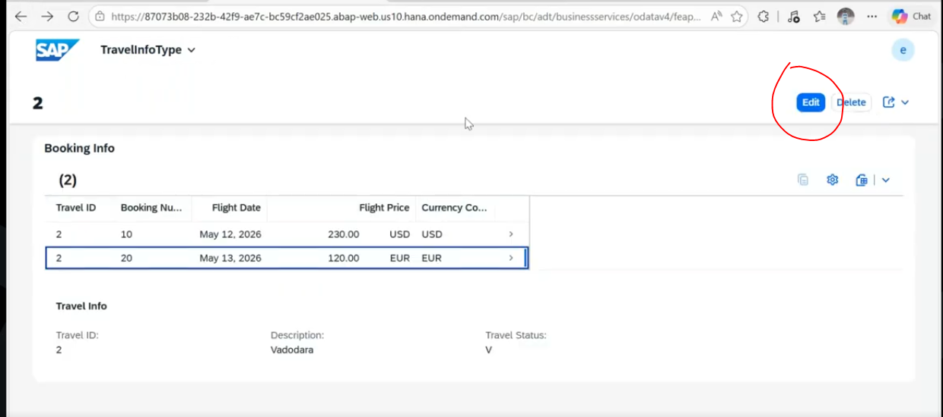
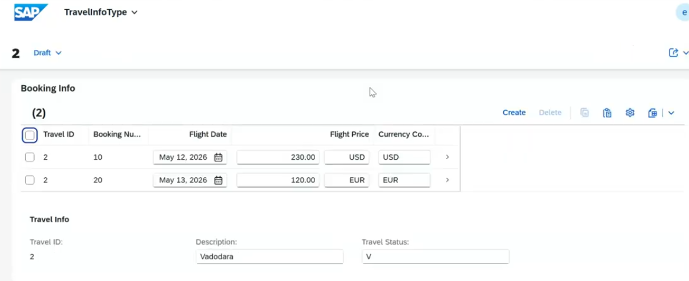
at a time you can update multiple items and change it and save.
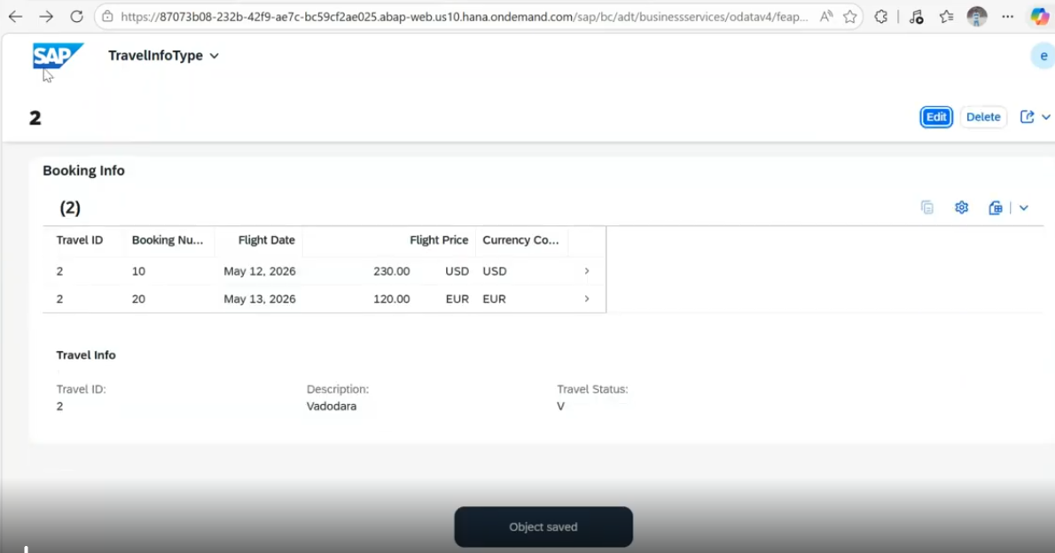
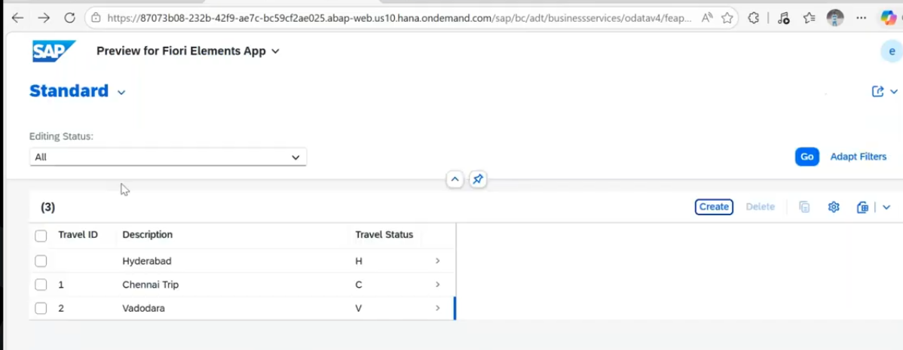
When you click on master record.
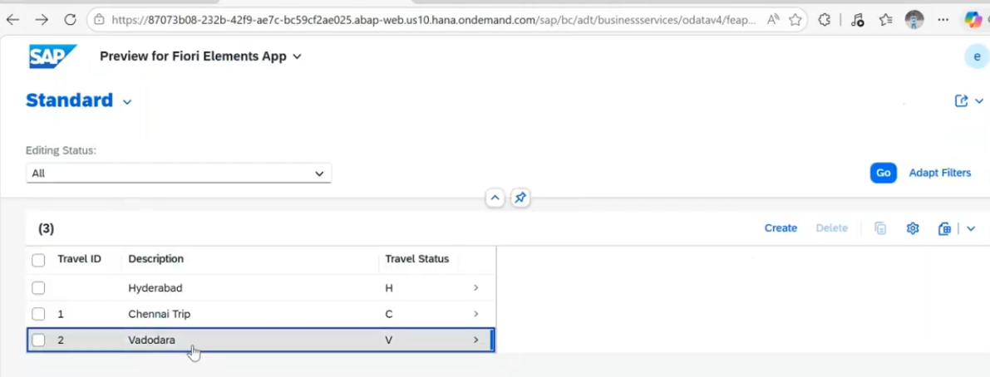
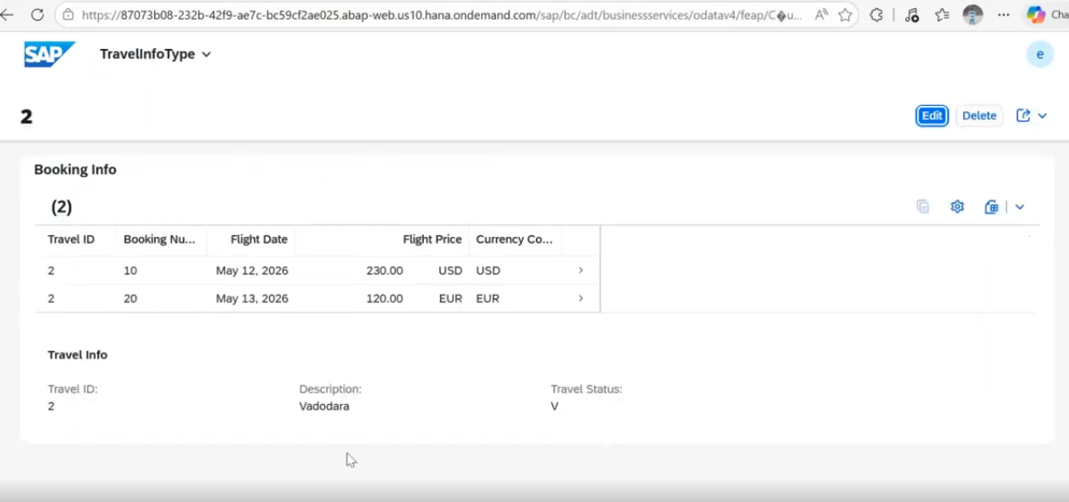
Item data is available in the form of a table format.
this the way you can perform multiple entities.

